**LAB REPORT NO 2**



**Spring 2020**

**CSE-202L Digital logic design lab**

Submitted by:  **Muhammad Ali**

Registration No:- **19PWCSE1801**

Class Section: A

“On my honor, as student of University of Engineering and Technology, I have neither given nor received unauthorized assistance on this academic work.”

Submitted to:

**Engr. Abdullah Hamid**

(December 13, 2020)

Department of Computer Systems Engineering

University of Engineering and Technology, Peshawar

**LABORATORY EXERCISE # 2**

**TITLE**  **“STUDY OF BASIC GATES”**

**Objectives:**

* To study basic gates.
* To determine the ground and VCC terminal of gates.
* To verify gates with truth table

**APPARATUS**:-

Power Supply, Breadboard, Connecting Wires.

**COMPONENTS ICs :-**

7400, 7402, 7404, 7408, 7432, 7486, DIP Switch and LEDs.

**Theory introduction:-**

Logic gates are the digital circuits with one output and one or more inputs. They are the basic building blocks of any logic circuit. Different logic gates are : AND, OR, NOT, NAND, NOR, EX-OR. Digital circuits have two discrete voltage levels to represent the binary digits (bits) 1 and 0. All digital circuits are switching circuits. Instead of mechanical switches, they use high-speed transistors to represent either an ON condition or an OFF condition. Various types of logic, representing different technologies, are available to logic designers. The choice of a particular family is determined by factors such as speed, cost, availability, noise immunity, and so forth. The key requirement within each family is compatibility; that is, there must be consistency within the logic levels and power supplies of various integrated circuits made by different manufacturers. The experiments in this lab use primarily transistor-transistor logic, or TTL. The detailed performance characteristics of TTL depend on the particular subfamily. However, all TTL is designed to operate from a 5 V power supply, and the logic levels are the same for all TTL integrated circuits.

**Verification of OR gate with truth table:-**

**OR gate:-**

Logic eqn. Y=A+B. The output of OR gate is true when one of the inputs A and B or both the inputs are true. Y=1 if A=1 0r B=8 0r both A=1 B=1.

# **IC PINOUTS** **TRUTH/FUNCTION**

Table

|  |  |  |
| --- | --- | --- |
| A | B | Y=A+B |
| 0 | 0 | 0 |
| 0 | 1 | 1 |
| 1 | 0 | 1 |
| 1 | 1 | 1 |

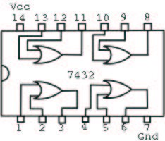

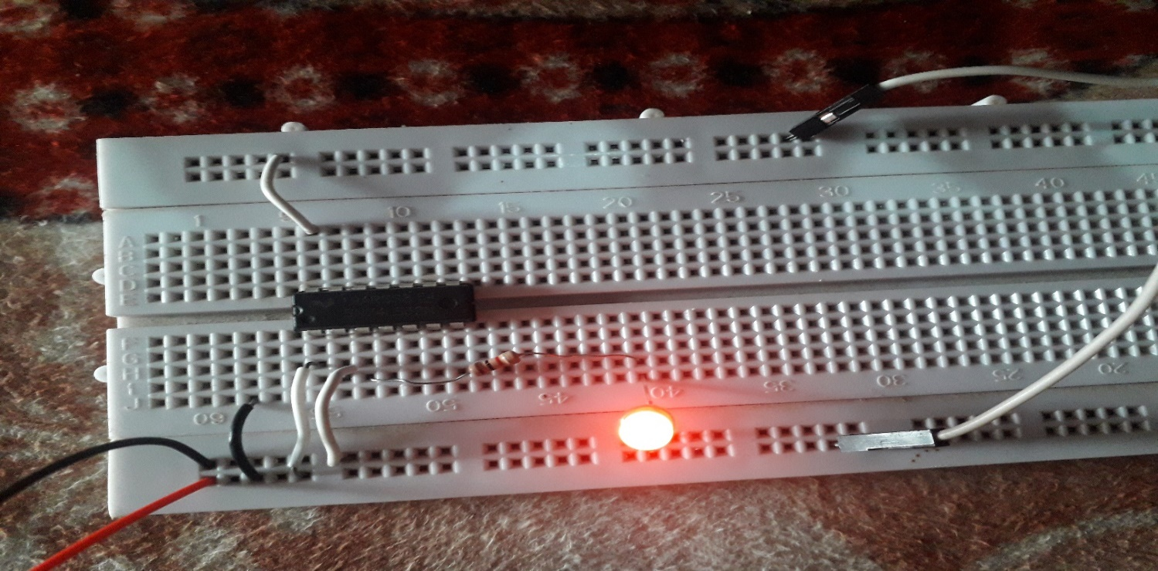

Note:- input =10

**Procedure:-**

* First we insert OR gate in the middle rows at breadboard.
* The 14st terminal (VCC) of gate is connected with positive terminal of the power supply and the 7th (ground) is connect with negative of power supply.
* We give two input to terminals 1st and 2nd, and take output from 3rd terminal by inserting LED.
* Input of 0 means ground and input of 1 means VCC.
* We have four possible combine input of two inputs, i-e (00,01,10,11) and output by LED with (OFF,ON,ON,ON) respectively.
* This is how we verify OR gate with truth table.
* Same steps are repeated for verification of AND,NOT,NOR,NAND,XOR etc.

**AND gate:-**

Function expression for AND gate is y=A.B ,the output of and gate is Y=0 if A 0r B is equal to 0,and Y=1when both A=1 and B=1

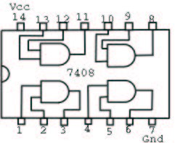

|  |  |  |
| --- | --- | --- |
| A | B | Y=A.B |
| 0 | 0 | 0 |
| 0 | 1 | 0 |
| 1 | 0 | 0 |
| 1 | 1 | 1 |

**NOT:**-

Logic eqn. Y = Aˊ. The output of NOT gate is complement of the input.

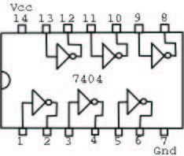

|  |  |  |
| --- | --- | --- |
| A | B | Y=Aˊ |
| 0 | 1 | 0 |
| 1 | 1 | 0 |

**NOR:-**

Logical eqn.  . The output of NOR gate is true (Y=1) when both the inputs are low.otherwise Y=0.

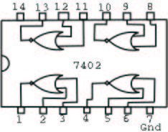

|  |  |  |
| --- | --- | --- |
| A | B | Y=(A+B)ˊ |
| 0 | 0 | 1 |
| 0 | 1 | 0 |
| 1 | 0 | 0 |
| 1 | 1 | 0 |

**NAND:-**

Logic equation.  . The output of NAND gate is true when one of the inputs or both the inputs are low.

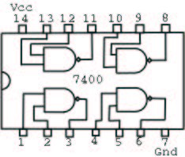

|  |  |  |
| --- | --- | --- |
| A | B | Y=(A.B)ˊ |
| 0 | 0 | 1 |
| 0 | 1 | 1 |
| 1 | 0 | 1 |
| 1 | 1 | 0 |

**EX-OR:**-

Logic eqn.  . The output of EX-OR gate is true when both the inputs are dissimilar.

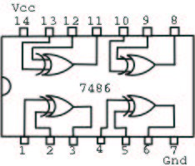

|  |  |  |
| --- | --- | --- |
| A | B | Y=A⊕B |
| 0 | 0 | 0 |
| 0 | 1 | 1 |
| 1 | 0 | 1 |
| 1 | 1 | 0 |

**Conclusion:-**

After performing the experiment for OR gate and then repeating all experimental steps for other gates (AND,NAND,NOR,EX-OR,NOT) we prove all the truth table for each gate separately.

**REVIEW QUESTIONS:-**

1. **A burglar alarm for a car has a normally LOW (grounded) switch on each of four doors. If any door is opened, the output of that switch goes HIGH. The alarm is set off with an activeLOW output . What type of gate will provide this logic?**

**Answer:-**

**OR** gate will provide this logic of a burglar alarm for a car. Because switch of the alarm has to become high when any door is opened, if any door is open the switch will output high.

1. **If more than two input AND & OR gates are available, how will you connect its inputs so that they work as two input gates? Perform it for three and four input AND & OR gates.**

**Answer:-**

**For three AND gate:-**

We can connect three input using two AND gates which work as two inputs. A.B is the first input and C is the second input. As shown in the diagram.

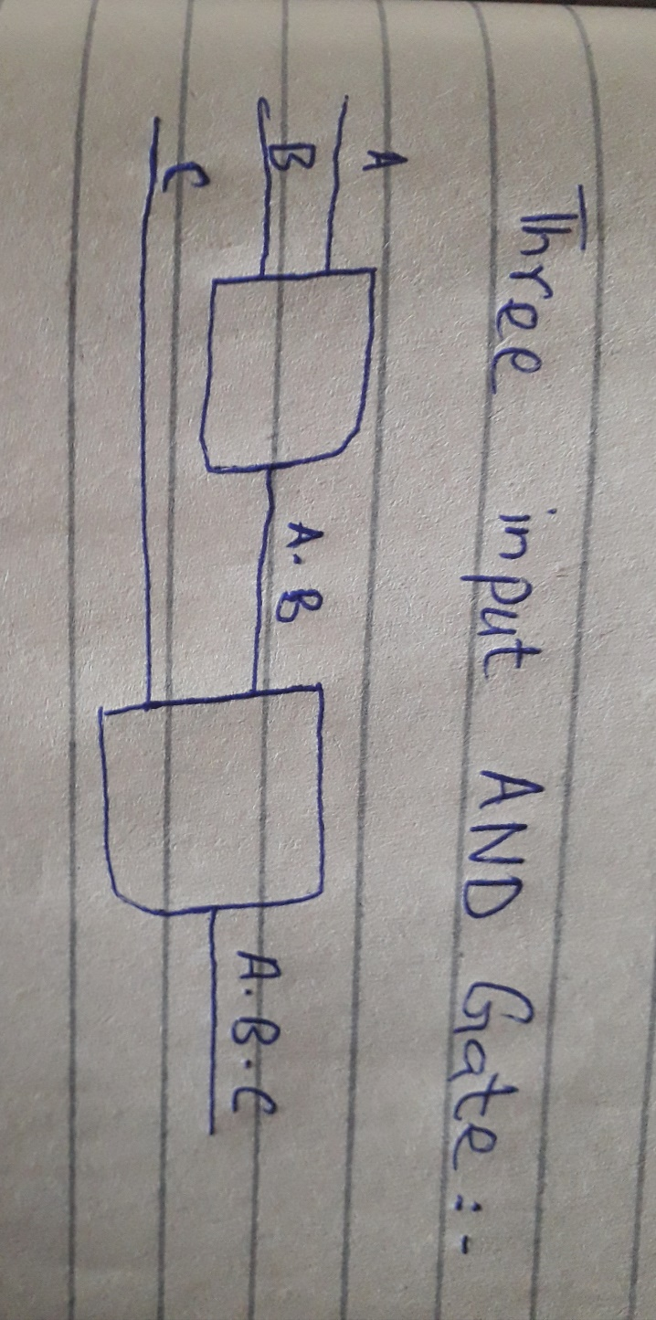

**For four input OR gate:-**

By using three OR gates we can connect four inputs gate to two input gate, first input is A+B+C and the second input is D. As shown in the written diagram.

